# NAME OF GAME

Dominic McNeill – 102061800

# Table of Contents:

Contents

NAME OF GAME 1

Table of Contents: 2

# Requirements:

Interaction system with tooltips - outline shader should be displayed. (just change the material)

Inventory system (going to be slot based) - pick up items, discard items and use them.

Subtitle typewriter system with voiceover (subtitles) - VO should be synchronised.

Document viewing system. (use interacting system to display a readable document, same font as game world). (with overlay toggle to make text readable). (input locks). - back faded background. (key inputs should be rendered on the side).

Keypad puzzle. (connected to something). Zoom into keypad smoothly and change to keypad view. - should glow.

- all keys to display digit on-screen.

- require 4-digit code.

- LED lights should glow depending on right or wrong.

- clear key, delete key, confirm key.

Do not immediately clear the digits, leave them for a few seconds.

## Extra:

each key on keypad is highlighted.

3rd and 1st person mode.

implement controller support. buttons icons change according.

make the room bigger and make a monster AI.

make pickup able journal inventory.

maintainability index of 90+

# Premise of game:

Story background, space freighter carrying cargo but one had a unknow life form inside. The ship crashes and the container breaks. No rescue will come, and the ship is programmed to self-destruct, and all escape routes are locked.

The main enemy is the AI and the level access the player has. They are powerless in stopping the ship’s self-destruct.

The “horror” is the game will be more atmospheric rather than a horror game (Scope) so as the player is playing, they should be put on unease. The quite rumbling, the AI speaking and echoing. The mysterious quite sounds in the background that play that does not fit in. (yes, a bit of FNAF audio moments).

# Pass #1:

## UI (wireframes):

### Main menu:

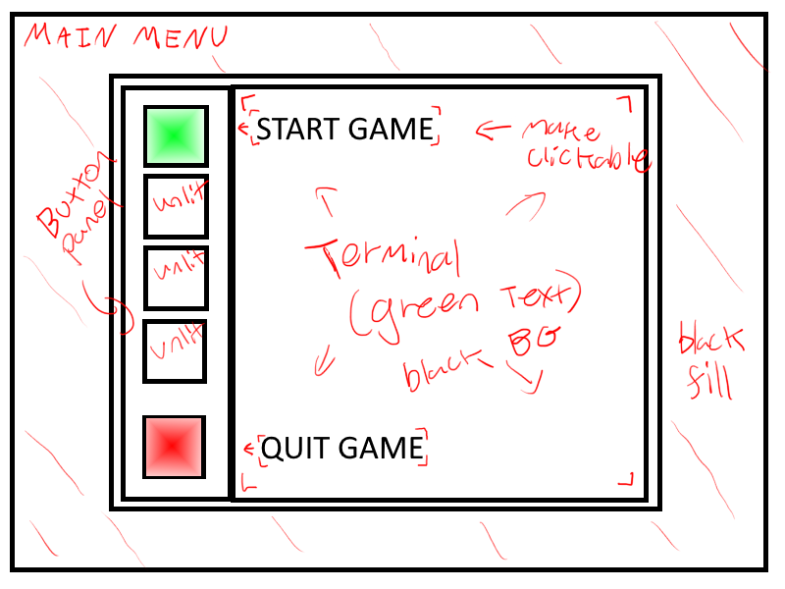

### Pause menu:

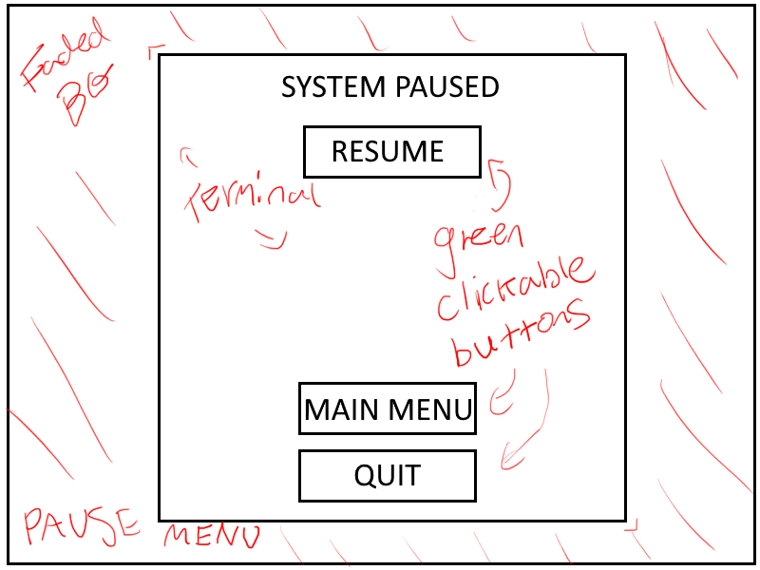

### Inventory menu:

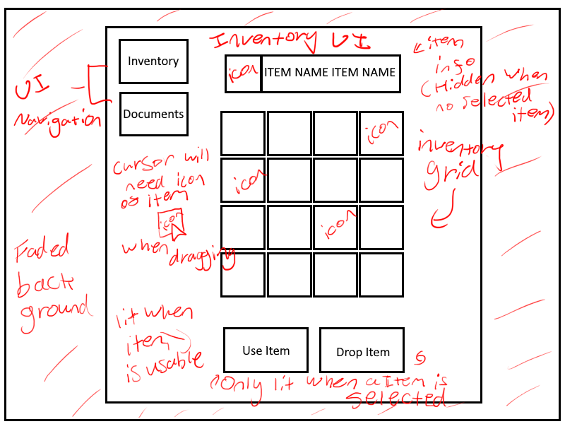

### Document menu:

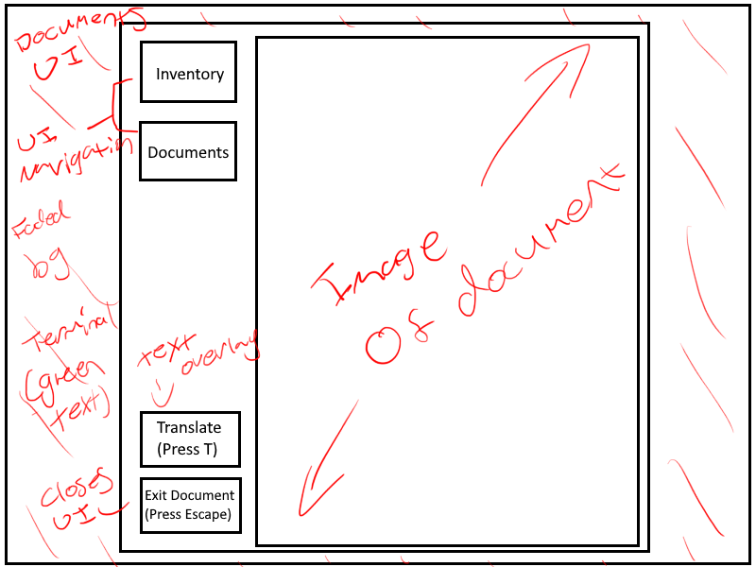

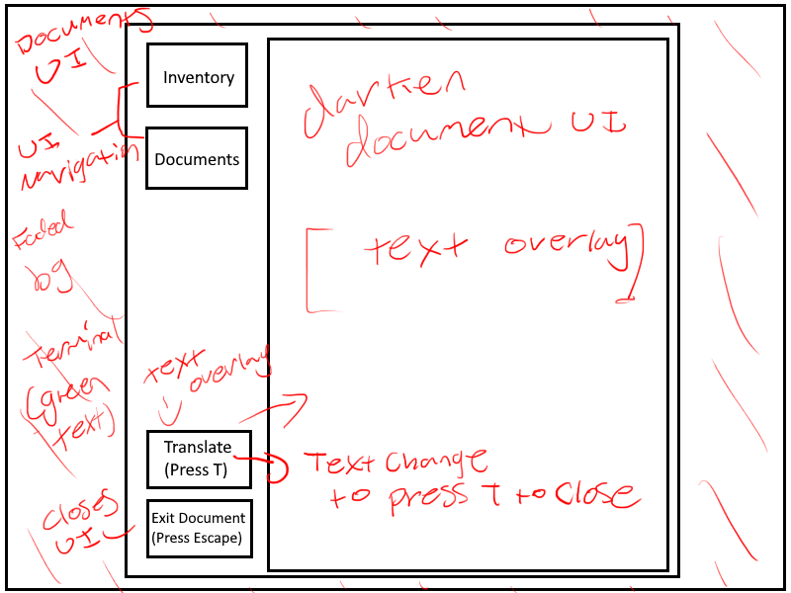

## Test Plan #1: